HB-S |  | LSZF: 056 464 40 40 | Flugplan CH: 0800 437 837 | ETA_{max}
DV20 | Zähler |  | Ausland: +41 43 931 61 61 | ETE
4
2
6
8
10
14
12
16
20
18
22
24
26
30
28
QNH |  |  |  |  | ALTERNATE FRQ/runway/altitude/Outbound/Zoll
SQUAWK
RW |  |  | INFO |  | Departure FRQ/runway/altitude/Outbound/Zoll
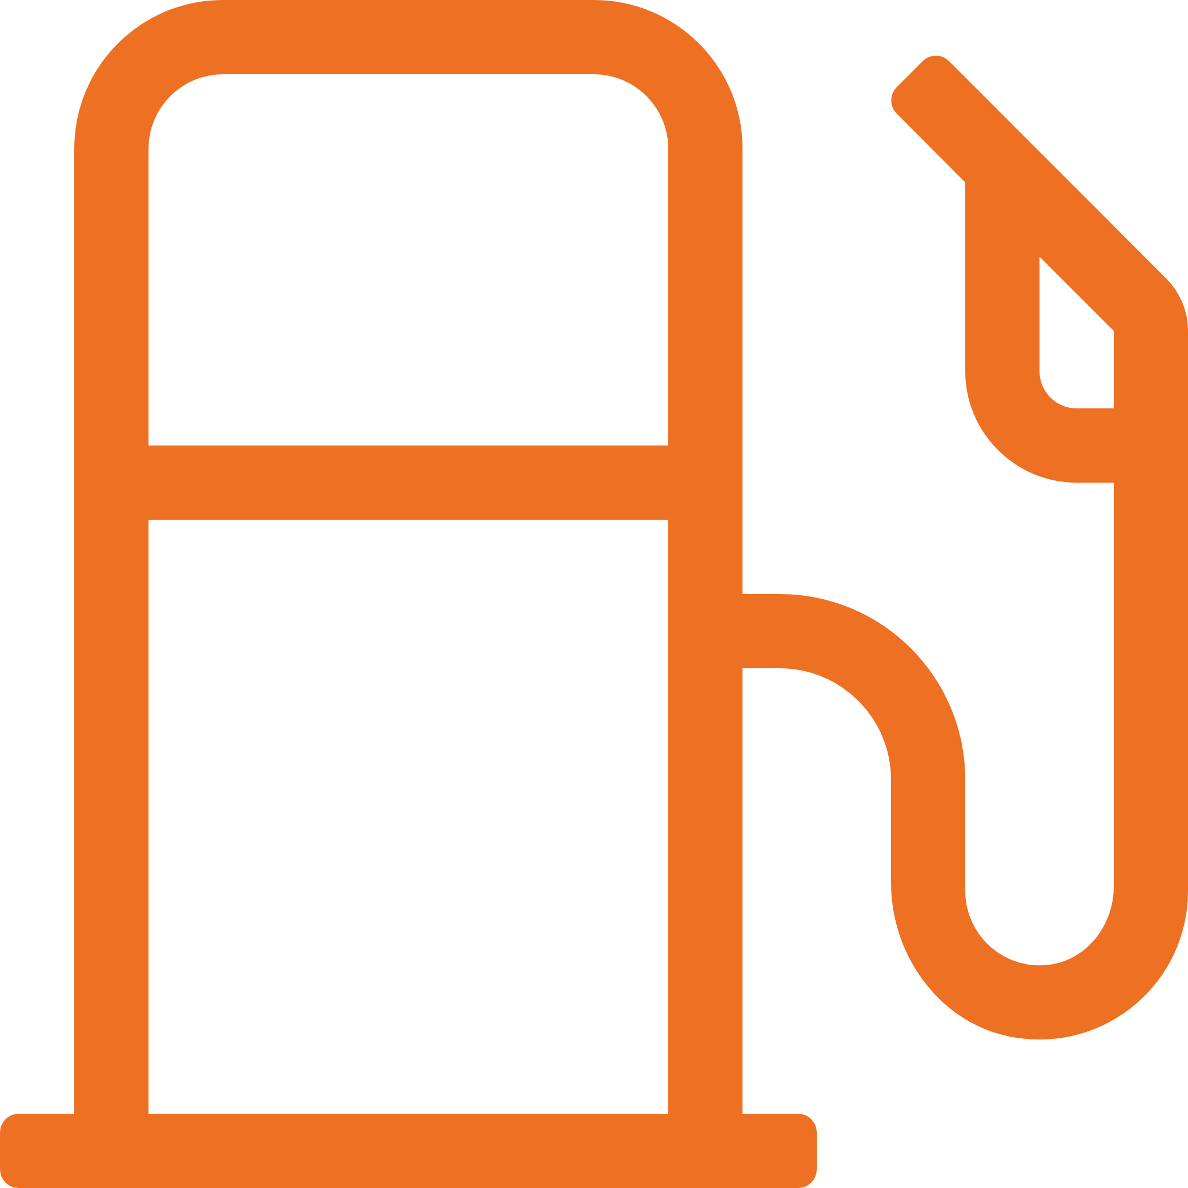
Fuel _{t/l}
22l/h
Info # EM: 134.130 | BA: 134.675 ° 130.9 | GE: 126.350
Twr # EM: 118.0 | BU: 119.625 | ME: 130.150
Atis # ZH: 129.005 | AD # BI: 123.555

 | Waypoints |  |  | MT | EET | ETO | ATO | V_{x} |  | 58 |  |  | V_{y} | 65 |  | V_{a} | 100 | V_{bg} | 70 | V_{gs} 60
 |  |  |  |  |  | DEP» |  | GPS |  |  |  | IMPORTANT / FRQ / ALTITUDE
 |  |  |  |  |  |  |  |  | FP
 |  |  |  |  |  |  |  | FP
 |  |  |  |  |  |  |  | V_{f}: 60 | C_{w}: 15
Destination _{FRQ/runway/altitude/Outb./Zoll} | Startup Departure Info TMA Cr. CTR Cr. Arrival  HB- HB- HB- HB- HB- HB-  Position Holding p./b. DV20 DV20 DV20 VFR from  VFR to Outbound VFR from/to VFR from | to Position Position  Information Req. turn right Position Position Request Info  Outbound Ready for dep Routing POB Via  Request T. POB | EET Dep. Time + FP request For Landing

Line Up |  | Canopy/door, Windows, Landing Light, Strobe Light, Time / GPS, Approach sector & runway || Pw 25
Climb |  | Flaps, Throttle, Fuel pump, landing light, Flarm
Cruise |  | Altimeter, Gyro, Power, Fuel
Descent |  | ATIS, Approach briefing, Avionics, Gyro, Cabin and Pax
Approach |  | Altimeter, Landing light, Fuel: Endurance, pump, Carburator heat ↓, RPM (21)
Overhead |  | T, Windsack, Traffic, Point of descent, Ziellandung
Power setting |  | Downwind: 21 RPM - Power 23 || Point of descent: Power 15
Final |  | Flaps, max RPM, carburetor heat ↑
After landing |  | Transponder, Strobe light, Fuel pump, Flaps
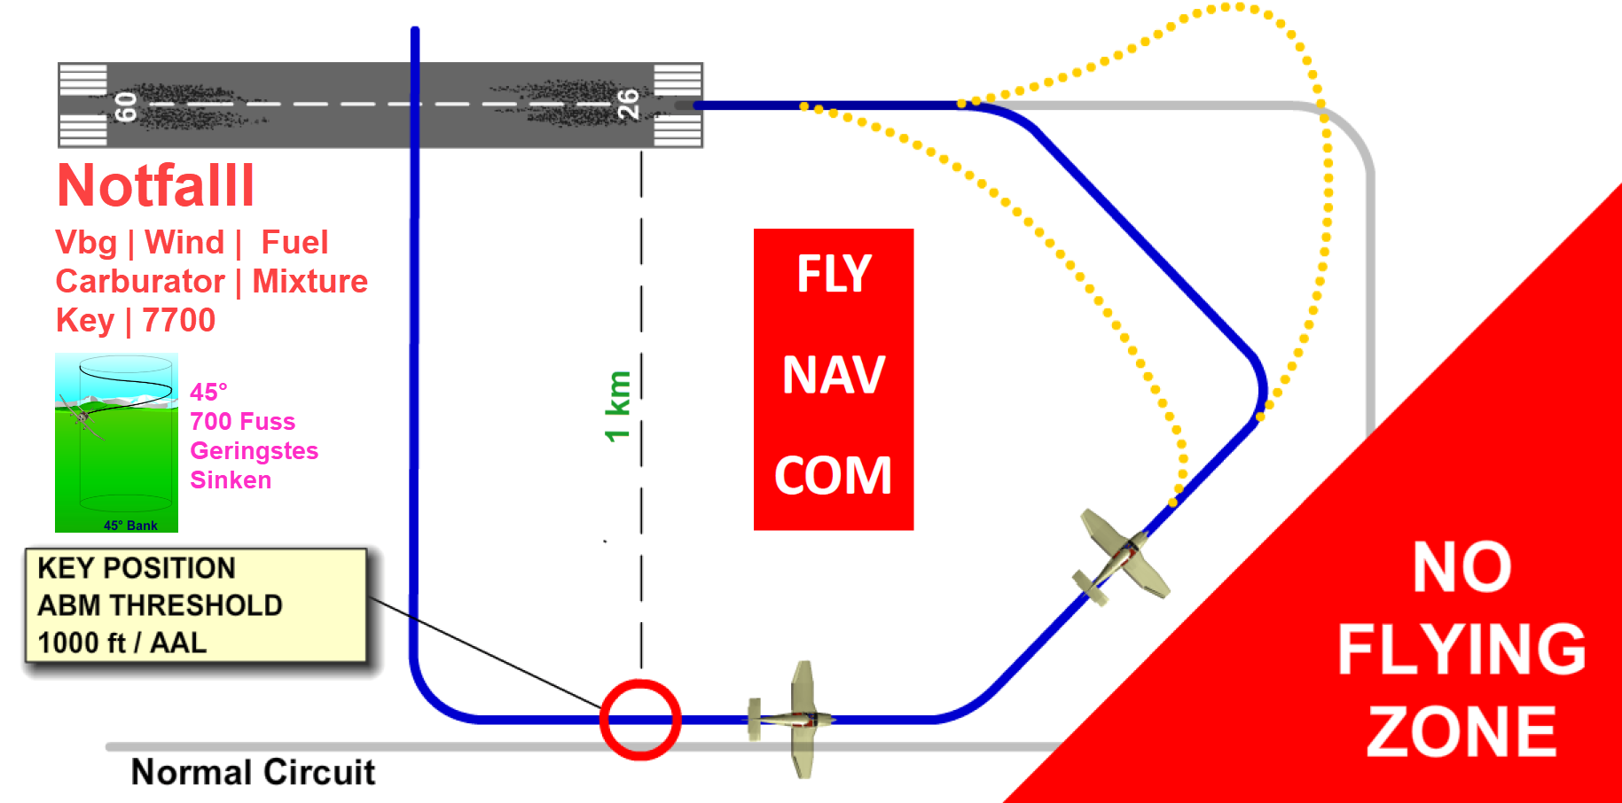 | SPORDEC | Take time!  Situation (fuel, weather, zoll…)  Preliminary action  Optionen (brain storming)  Rating (Vor- und Nachteile)  Decision  Execution  Controlling (-> S.?)

NR | E
 |  | Flugbuch, Lizenz, Medical, ID
 |  | Kopfhörer - Batterien geladen
 |  | Tablet für Navigation (Hauptgerät), geladen, Passwort | Kniegürtel
 |  | Tablet für Navigation (Reserve), geladen, Passwort
 |  | Zusatzbatterie, Ladegerät, Kabeln, Ersatzkabeln, Adapter, Verteiler
 |  | Laptop, Mouse, USB-Stick | Notizbuch | Multifach-Mappe | Minitasche
 |  | Start | Navigationsplan
 |  | NOTAM: Flugplätze
Öffnungszeiten: ATC, Flugplatz, Fuel (AVGAS) | Kosten: Flugplatz, Fuel | Sprache
Parking – Verfügbarkeit | Pilot Notes
 |  | Zoll (Dep-Arr): Zeiten-Kriterien (LSZF) | D: ZFP - VRZF | F: PPR 24h or 48h
 |  | Weight & Balance, Startrollstrecke, Startleistung (S. 8): AFM (Kap. 5)
 |  | SD: METAR, TAF, GAFOR, Wind, Rain | Windy: Sicht, Niederschläge, Wind: Piste
 |  | Route: Topografie, Luftraum, Bestimmungen, Notam oder DABS (Optimale Höhe, min. or max. Höhe, alternative Routen wegen Wetter oder ATC)
 |  | WP Descent Check (DC) | Approach Check
 |  | Point of descent (POD) (500 F = 1 nm) | Landeprozedur
 |  | Frequenzen: Info, ATC
 |  | Sprüche für ATC
 |  | Route in der Cloud (für Tablet, mit aktuellen VAC- und Transitkarten)
 |  | SkyDemon-Karte auf Papier oder ICAO-Karte
 |  | Karten auf Papier (Departure, Destination, Alternate. Transit-Karten) | Bostitch
 |  | Leere Navigationspläne (als Reserve)
 |  | 2 gespitzte Bleistifte
 |  | Next service | Flugzeugdaten: MTOW:730kg, Noise: D, Quer: 10.7m, Länge:7.3
 |  | Flugplan: Verteileradressen: LSZFZTZX | Ausrüstung: GOY S | EET/XXX0008
 |  | Roaming, Internet im Ausland
 |  | Gelbe Weste (High-visibility safety clothing)
 |  | Schwimmweste
 |  | Essen, Trinken
 |  | Geld (CHF, Euro, Kreditkarten) | Hotel | Taxi
 |  | Gesundheit | Sonnenbrille, Sonnencreme, Lippe, Hut, Maske
 |  | Navigationsplan auf Papier (rechtes Knie)
YJ = Yellow Jacket | HP = Headphone | C = Custom | Pl = Pillow
S = Schwimmweste | Öl | Pz = Putzmittel (Wasser, Papier)
